Instructions for Poster Preparation of 2024 SPWLA Symposium in Rio de Janeiro, Brazil

ALL POSTERS SHOULD BE PREPARED IN PRINTED FORMAT: All posters need to be printed on large paper format (see below for specific dimensions) and will be affixed to stands.
GENERAL: Many of those viewing your poster will do so from about a distance of 4 to 6 feet. Most material prepared for a printed page (magazine, journal, book, etc.) is NOT suitable for posters. Grid lines, log traces, small letters, and numbers that are perfectly readable on a printed page may be impossible to read at a normal poster viewing distance. If your graphic material is not legible at normal poster viewing distance it should be redesigned and/or redrafted for your poster presentation. A Best Poster Presentation Award will be given by the Technology Committee to encourage the highest quality in poster presentations.

EQUIPMENT: Posters sheets should not be larger than 180cm height x 180cm width. The poster board itself is 120cm height x 180cm width. Posters sheets will be attached with double-sided tape. The double-sided tape will be provided by the poster stand vendor.
POSTER TITLE: The poster title and authors should be identified in large letters, at least one inch in height.
DISPLAY TIME: Posters must be on display by 8:00 AM, Monday, May 20th. All authors are required to be at the poster during their assigned session on Monday, Tuesday or Wednesday (see the final technical program), which are dedicated sessions for poster viewing. Posters are to remain up for the duration of the Symposium. Please remove your poster after 5:00 PM Wednesday. Any poster left there after 5:00 PM on Wednesday will be discarded.
POSTER LOCATION: Posters will be located in their prominent designated area. You will be told where to place your poster when you register at the Symposium.
AVOID COMMERCIALISM: The same conditions that apply to your paper, apply to your presentation. Please make every effort to avoid commercialism in your poster. The objective should be to inform the audience rather than to promote a specific service. Please avoid excessive use of trademarks, commercial service names and names of employers. Generally, company logos may appear with the title or the authors’ affiliations, but should not appear thereafter in the presentation. As with papers, logos beyond the title can result in rejection. Required copyright notices may be placed in small typeface in the lower corner of each poster but should not include repetitive logos.
An article that discusses the planning and design of successful poster presentations appears below.

Excerpts from a brief note entitled, Poster Sessions: An Alternative to Formal Oral Presentations, by R C. Severson, L. P. Gough, J. M. McNeal, and L. H. Ropes
Poster sessions can be very effective in communicating certain types of information. Authors should carefully plan poster design and construction so as to obtain the most efficient and effective presentation. Second-class status should not be ascribed to a poster session either by the organization or by the participants. Poster presentations should receive equal billing with oral presentations. Our experience indicates that as much planning and work are needed for a poster presentation as for an oral presentation.
For authors, the opportunity for individual contact and extended dialogue is rewarding. Many authors and discussants feel more comfortable in a leisurely discussion than in a condensed formal oral presentation. Posters allow considerable variety in graphic displays such as maps, charts, photographs, and computer output and may also include carefully worded statements, claims, conclusions, and principles. Viewers may evaluate this information at their own pace; thus they have time to contemplate, discuss, and return to review posters of interest. The author's working address, phone number and convention address should be included on the poster. Author accessibility permits interested viewers to discuss specific points either in the poster area during the scheduled time or at other times and locations that are mutually convenient.
Thoughtfully organized posters should provide an ordered, logical path along which the viewer is led. This can be easily accomplished by the use of arrows and colors and by the general organization of the poster. The main points of the poster should be clear, and the flow of the discussion should be readily apparent to the viewer. Convention suggests that the line of thought should proceed from upper left to lower right. As in any presentation, it is best to choose a representative example of the principles being considered and follow it through from beginning to end, so that the viewer may readily understand how the data support the conclusions. In order to attract attention, the title, purpose, and conclusions should be emphasized by color, print size, location on the poster, or by combinations of these factors. A poster, like an oral presentation, should avoid excessive detail; therefore, discussion, graphs, and tables should be simple. The more important material should be emphasized by size or highlighted with color, while minor details should be subordinated or omitted. A handout can be made available to present more detail if desirable. Author-prepared posters are more common than professionally prepared posters. The use of large-type typewriters, lettering tools, typeset printing, and even careful hand-lettering have all been successful. In any case, lettering should be sufficiently large for most of the messages to be legible at a distance of 4 to 6 ft.
Poster sessions are well worth the substantial effort required.

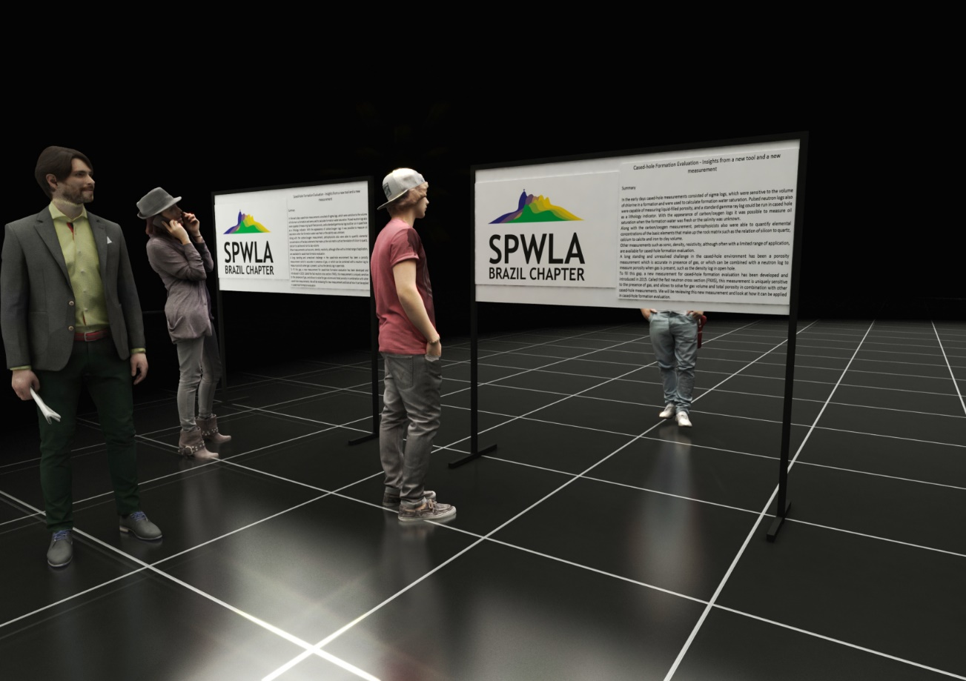

Samples of the Poster Session Setup

