Workshop 1 Course Title: Advanced Borehole Image Applications – Reservoir characterization beyond dips

Date: Saturday, May 18, 2024

Summary
For this 2024 advanced borehole image applications educational workshop we will present a technique that integrates borehole image logs, conventional petrophysical logs, lab results and DST for modeling porosity and permeability in pre-salt carbonates. Since its development, this technique has changed the way pre-salt carbonates are modeled, becoming part of the petrophysicists and geologists’ workflows.

Expectations (what you will get)
Participants will be given a brief introduction to the main types of borehole image logs and the methods used for their acquisition. They will then dive into a digital rock-based approach for quantitative analysis of acoustic image logs, gaining an understanding of the data structure and limitations. Finally, participants will get to know how matrix and extra matrix porosity have been modelled, as well as the permeability in karstified reservoirs. Case studies of pre-salt carbonates will be presented. Participants are encouraged to bring computers with Microsoft Excel installed, as it will be used for practical exercises. (A few extra computers will be available for those who eventually are unable to bring their own.)

Workshop 1 Course Outline (Timing Goal: 9 hours total including breaks)

- 08:00am Introduction of Course and Instructors – Peter
Welcome + previous experiences in the group.
- 08:20am Overview on borehole image logs acquisition and tools – Peter / Susana
Introductory talk with focus on types of image logs and acquisition methods
- 09:10am Quantitative analysis using borehole image logs – Candida / Camilla
Data structure and limitations. Acoustic image logs and porosity - which data should I use? Why should I want to use this data for petrophysical modeling? Karst interpretation on image logs and pitfalls. Best practices for matrix porosity quantification and how to extract and model extra matrix porosity logs. Exercises.
- 12:00pm Lunch
- 01:00pm Extra matrix porosity and matrix porosity characterization - Candida / Camilla
Phi-mgp, karst index and morphological properties - Exercises.
- 01:30pm 1D Permeability Modeling in karstified carbonates- André /Candida/Camilla
Permeability modeling integrating borehole image logs, NMR, Kabs and DST measurements - Exercise in Excel
- 03:00pm Karstified reservoirs geocellular modeling – Camilla
How BHI attributes have been used to improve karstified reservoirs modeling
- 03:50pm BHI logs new frontiers – Chandramani
What is expected from the new developments on AI, new tools and applications.
- 04:40pm Final remarks - All presenters
Attendees discuss some of their exercises.
Who Should Attend? This workshop is primarily aimed for petrophysicist, geologists or petroleum engineer with an interest in BHIL logs and carbonates petrophysical characterization.
Prerequisites: A basic understanding of borehole image logs and petrophysics will make the course more useful.
Teaching Methods / Handouts: The course will be in person and discussions will be off the record to encourage participation. Virtual participation will not be available. Printed content will be provided.
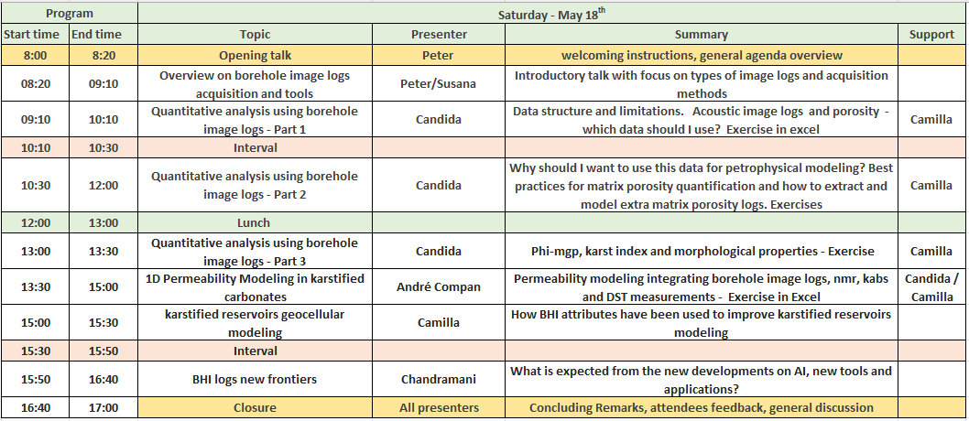
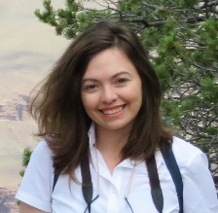
Workshop 1 Course Instructor Biographies:
Candida Menezes is a senior petrophysicist specialist in borehole image logs based in Rio de Janeiro. She coordinates research projects in artificial intelligence applied to petrophysics. Candida joined Petrobras in 2007 as part of the exploration team of the International Business Unit and currently works at Reservoir Development and Production. She graduated with a Batchelor in Geology from Rio Grande do Sul Federal University and has M. Sc. (2004) from Rio de Janeiro State University (UERJ). Candida´s interests include petrophysics, karsts, borehole image logs and artificial intelligence. Apart from work, she likes spending time doing sports and writing an endless fantasy book.
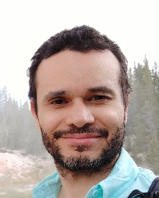
Andre Compan is a senior petrophysicist focused in special core analysis. He graduated in Mechanical Engineering in 2001 and holds a Doctorate (D.Sc.) in Relative Permeability Rocktyping from the Federal University of Rio de Janeiro (UFRJ). Since 2005, he has worked as a consultant at the Petrobras Research Center (CENPES), mainly on rock characterization and R&D. Compan serves as the SCAL consultant at CENPES and leads various projects primarily related to Relative Permeability. His interests include petrophysics, relative permeability, capillary pressure, uncertainty evaluation, artificial intelligence and, not less important, traveling and sports, e-sports 😉.
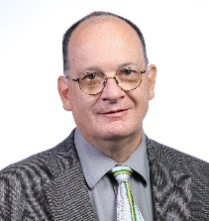
Peter Barret Graduated with a Batchelor of Science in Mathematics, Modelling and Computing from Kingston University in London. He has over 30 years of experience working with image logs around the world, in Geoscience, Software Development and SME roles at both service companies and independent consultancies. He believes when it comes to processing “You have never seen it all” and enjoys the enhancements in data quality and integrated analyses which increase the overall value of an image log to an operator. When away from work he can be found enjoying time with his family or working on an old car.

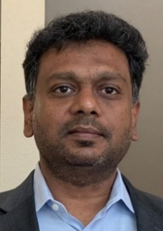
Chandramani Shrivastava is Geology Advisor and Global Domain Head for Schlumberger Well Construction with 22 years of experience in data management, formation evaluation and workflow engineering across India, Middle East, Southeast Asia, West Africa, Caribbean and the US. He is based out of Well Construction HQ in Sugar Land (Texas, US). He is widely published on borehole images and has been advising on technology development and deployment of wireline and LWD borehole imagers. He has served as SPE Distinguished Lecturer, and currently is International Chair for AAPG Students’ Chapter. Chandramani holds Master’s degree in Applied Geology from IIT-Roorkee (India) and another Master’s degree in Petroleum Engineering from Heriot-Watt, Edinburgh (UK).
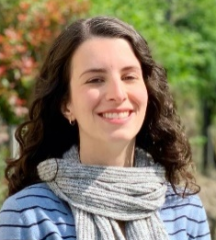
Camilla Bazzarella is a senior petrophysicist at Petrobras. She earned her Bachelor’s degree in Geology at Federal University of Rio de Janeiro (UFRJ) in 2011 and joined Petrobras the following year. She began her career working as a 3D-modeling geologist for the Albian carbonate reservoirs of Tartaruga Verde, a deepwater oifield in Campos basin, offshore Brazil. Then, in 2019, she decided to make a career shift to Petrophysics. Camilla currently works as the lead petrophysicist for the pre-salt carbonate reservoirs of Sepia, an ultra-deep water oilfield in Santos basin, offshore Brazil. She enjoys spending her free time with her family and her dogs.
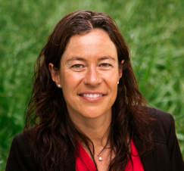
Susana Gutierrez Carrilero earned her Master’s Degree in Civil Engineering from Politechnical University of Catalonia based in Barcelona, Spain. Having 19 years of experience with Halliburton Sperry Drilling, she has been an LWD engineer in West Africa, a geosteering specialist in the USA, Mexico, and Europe, a Principal LWD Technical Advisor in Denver, CO and currently serves as Global Product Champion for LWD Imaging. Prior to her time with Halliburton, Susana worked as an LWD Engineer in Norway and West Africa for Schlumberger.
.

