Workshop 2 Course Title: Enhancing field understanding and well placement with Deep and Ultra-Deep Resistivity Mapping.

Date: Saturday May 18, 2024

Summary
The adoption of Deep and Ultra-Deep Azimuthal Resistivity (DAR/UDAR) systems is on the rise, unlocking a mid-scale view of geology in real-time. These systems serve as a bridge between the borehole scale from conventional well logging and the seismic scale. By providing early warnings, far-field investigation significantly reduces well misplacement in reservoirs while enhancing structural understanding and identifying formation and fluid distribution. But how does the far-field connect to the near-wellbore measurements and what are the synergies and the limits an interpreter needs to know before making decisions.

This workshop covers DAR/UDAR as well as high angle petrophysics principles and the latest innovations in measurement processing and visualization. Practical cases demonstrate how this technology optimizes well positioning and formation mapping. Geosteering simulations encourage active participation, and a roundtable discussion aims to enhance reservoir understanding and wellbore placement.

Expectations (what you will get)
Participants should leave this workshop with a good understanding of the theory and principle of Deep and Ultra-Deep Azimuthal Resistivity measurements, the different electromagnetic inversions principles, limits, benefits, and how to link the far-field information with the near-wellbore formation evaluation.

Workshop 2 Course Outline (Timing Goal: 8.5 hours total including breaks)

Presenters: Dr. Carlos Torres-Verdin (University of Texas at Austin), Dr. Nigel Clegg, Arthur Walmsley, Alban Duriez (Halliburton), Operator (pending travel approval)

This workshop will cover the following agenda:
- Safety moment
- Theory & status of the DAR/UDAR technology
- Live Exercise, Quiz with Prize format
- Case Studies
- Break for Lunch
- High angle petrophysics – the traps of Vertical vs Horizontal
- Connecting near and far-field information – state of the art and what comes next.
- Discussion session
- Quiz with Prize

Who Should Attend? This workshop is open to all symposium attendees who are novel or experienced users of DAR/UDAR and want to see how the far-field “tool” fits in the greater wellbore logging interpretation “toolbox”.
Prerequisites: A basic understanding of: Logging-While Drilling, Electromagnetics and Geosteering
Teaching Methods / Handouts: This course will be in person and discussions will be off the record to encourage participation. Virtual participation will not be available. Training materials will be available for attendees to download after the course.
Workshop 2 Course Instructor Biographies:
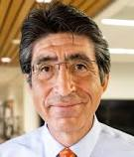
Dr. Carlos Torres-Verdín received a PhD in Engineering Geoscience from the University of California at Berkeley in 1991. During 1991-1997, he held the position of Research Scientist with Schlumberger-Doll Research. From 1997-1999, he was Reservoir Specialist and Technology Champion with YPF (Buenos Aires, Argentina). Since 1999, Dr. Torres-Verdín has been affiliated with the Department of Petroleum and Geosystems Engineering of the University of Texas at Austin, where he is currently a Full Professor, and holds the Brian James Jennings Memorial Endowed Chair in Petroleum and Geosystems Engineering. Dr. TorresVerdín is the founder and director of the Research Consortium on Formation Evaluation at the University of Texas at Austin. He is the recipient of the Cockrell School of Engineering’s 2016-2017 Lockheed Martin Aeronautics Company Award for Excellence in Engineering Teaching, the 2014 Gold Medal for Technical Achievement from the SPWLA, the 2008 Formation Evaluation Award from the SPE, and the 2006 Distinguished Technical Achievement Award from the SPWLA. He is a Distinguished Member of the Society of Petroleum Engineers (SPE), an Honorary Member of the Society of Exploration Geophysicists (SEG), and a receiver of the Conrad Schlumberger Award from the European Association of Geoscientists and Engineers (EAGE).

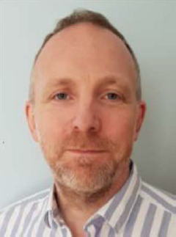
Dr. Nigel Clegg is the well placement subject matter expert and ultra-deep resistivity product champion for Halliburton. Clegg began working with Sperry Drilling (now Halliburton) in 1996 as an SDL field engineer in Norway, followed by working as a field service coordinator. Later, Clegg began working in geosteering, leading the Scandinavia geosteering team and supporting global operations. Clegg assumed his present role in January 2017, holding an Honours BSc degree in environmental sciences with a geology major and a PhD degree in geology from the University of East Anglia (Norwich).

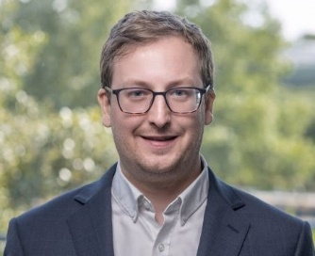
Arthur Walmsley is the global expert for reservoir mapping services at Halliburton. He graduated from Southampton University, UK in 2006. He has held a variety of technical positions at Halliburton in geological operations and management at regional and global level. He has published papers on well log interpretation, geosteering and reservoir mapping through SPE, SPWLA, EAGE and SEG

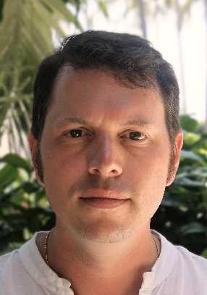
Alban Duriez is the Product Manager for Deep and Ultra-Deep Resistivity Technologies with Halliburton. He joined the company in 2007 as an LWD Field Engineer and has occupied various operational roles in Europe and Africa since. He moved to Houston in 2018 as a Product Manager, initially for LWD Telemetry, before transitioning to his current role in 2020. Alban holds an MSc in Geology (2002) and a PhD in Hydrogeology & Geochemistry (2006) from the University of Paris-Sud Orsay. He is a member of the SPE and SPWLA organizations and has authored publications related to MLWD technologies.

