Workshop 3 Course Title: Digital Rocks Demystified

Date: Saturday, May 18, 2024

Summary
For this 2024 digital rock physics (DRP) educational workshop we will cover both imaging and simulation techniques, focusing on real-world examples of applications.

Expectations (what you will get)
Participants will be introduced to the fundamental principles of X-ray imaging of reservoir rocks and fluids, in both static and dynamic cases. Starting from those images, the participants will be introduced to the main simulation techniques to generate SCAL and geomechanical data. Current trends in AI and challenges to expand the technique to multiple scales will also be addressed.

Workshop 4 Course Outline (Timing Goal: 8.5 hours total including breaks)

- 08:00am Introduction of Course and Instructors – Class introduction
João Paulo P. Nunes (Petrobras), Rodrigo Surmas (Petrobras), Avrami Grader (Core Labs), Nathaly Archilha (Sirius)
- 08:30am Introduction to DRP, Basic Concepts and Industry Examples – João Paulo Nunes
Introduction, motivation and the history of DRP in the O&G industry
- 09:30am Digital SCAL and the use of DRP in scenario analysis – Avrami Grader
Digital Core Analysis Overview, Simulation Techniques and Applications
- 10:30am The use of AI in DRP, upscaling and current trends – Rodrigo Surmas
Use of AI techniques for rapid turn-around and upscaling
12:00pm Lunch
- 01:30pm Imaging Techniques and Synchrotron sources – Nathaly Archilha
Overview of the principles of X-Ray imaging and the Sirius capabilities
- 03:00pm – Wrap Up – Roundtable and Challenges ahead.
Who Should Attend? Any geoscientist, petrophysicist, data scientist, or petroleum engineer with an interest in Digital Rock Physics.
Prerequisites: The course includes an introductory session on the basic concepts and is open to all levels of expertise. A basic understanding of Petrophysics and Petroleum Engineering is advisable.
Teaching Methods / Handouts: The course will be in person and discussions will be off the record to encourage participation. Virtual participation will not be available. Printed content will not be provided.
Workshop 3 Course Instructor Biographies:
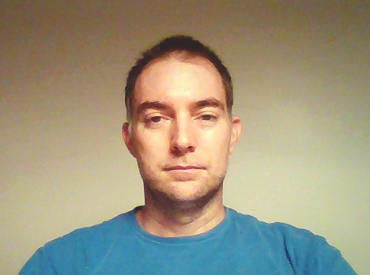
João Paulo Pereira Nunes is a senior advisor for Geomechanics and Rock Physics at Petrobras, Rio de Janeiro. He holds BSc and MSc degrees in Physics from Federal University of Rio de Janeiro and a PhD in Reservoir Engineering from Imperial College London. João Paulo has 18 years of experience as a reservoir geoscientist, working both at the pore and field scales. He is currently devoted to reservoir modelling and project assurance, where he is particularly interested in constructing physics-informed scenarios for production forecast and operational safety.

Rodrigo Surmas is an advisor for Digital Rock Physics at Petrobras Research Center, CENPES, in Rio de Janeiro. He has been working since 2001 on flow studies using numerical simulation, with applications to porous media and at Petrobras since 2008, focusing on the development of methods and processes for the characterization of porous media and determination of petrophysical properties based on imaging, numerical simulation, and artificial intelligence.

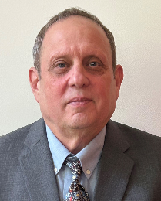
Abraham (Avrami) Grader - Core Analysis Domain Expert, Geosciences and Production, Wireline and Perforating, Halliburton. Avrami Grader interests are in multi-phase flow in porous media and reservoir heterogeneities Formerly, a professor of petroleum engineering at Stanford and The Pennsylvania State University, Grader focused on two- and three-phase fluid flow in porous media, transient pressure analysis with its effects on well testing and water influx, and multi-phase flow dynamics in the near wellbore domain including wellbore mechanics. He served as Ingrain Chief Scientist for nine years and now with Halliburton as Domain Expert in the core analysis and integration within the Geosciences & Production group. He is heavily involved in all aspects of integrating physical and digital core analysis methods and log upscaling. He is currently a global distinguished speaker for SPWLA, as well as the chair of the SPWLA scholarship committee in Houston. He holds a PhD degree from Stanford University.
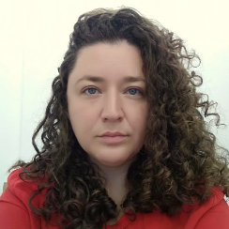
Nathaly L. Archilha holds a BSc degree in Physics (USP), MSc in Science (USP), and a PhD in Petroleum and Reservoir Engineering (UENF). Currently, she is a researcher at Sirius, the 4th generation Brazilian synchrotron light source (LNLS/CNPEM), overseeing the micro and nanotomography beamline (MOGNO), and coordinating the development and operation of this open facility. Nathaly leads several projects funded by energy industries, focusing on cutting-edge technology for high-throughput and time-resolved X-ray tomography experiments. Her work is dedicated to unveiling the porous structures and fluid dynamics of rocks samples under reservoir conditions.

