Workshop 5 Course Title: New Advances in NMR Techniques and Applications

Date: Saturday May 18, 2024

Summary
For this 2024 nuclear magnetic resonance (NMR) educational workshop we will get "back to basics" with three sub-topics: Core NMR, formation evaluation NMR (both wireline and LWD), and core to log integration. There will also be a brief introduction to NMR.

Expectations (what you will get)
Participants will be introduced to the fundamental physics and chemistry of reservoir rocks and fluids as illuminated by modern “everyday” and advanced NMR log and core analysis methods. Two introductory sessions will cover NMR physics and NMR core analysis. Next will be NMR logging and core analysis methods with a module on carbonates. The final session will be devoted to NMR core and log integration examples..

Workshop 4 Course Outline (Timing Goal: 8.5 hours total including breaks)

- 08:00am Introduction of Course and Instructors
Willian Trevizan (Petrobras), Jesus P Salazar (Baker Hughes), Kris Farmer (Core Labs), Nate Bachman (SLB)
- 08:30am Introduction to NMR - Nate Bachman
NMR basics, logging tool sensor designs, relaxometry, T1T2, and DiffusionT1T2
- 09:30am Introduction to Core Analysis using NMR - Kris Farmer
Core Analysis Overview, Laboratory NMR 2 MHz, Laboratory NMR 20 MHz
- 10:30am Principles of Formation Evaluation including NMR Part 1 - Jesus P Salazar / Willian Trevizan
Use of T1 and T2 distributions for formation evaluation: porosity, fluid saturation, permeability models and fluid typing.
- 12:00pm Lunch
- 01:30pm Principles of Formation Evaluation including NMR Part 2 - Willian Trevizan / Jesus P Salazar
Examples on carbonate evaluation.
- 03:00pm Core to Log Integration - Instructor TBC / Nate Bachman
T1T2 and DiffusionT1T2 core and log integration examples
- 04:30pm Wrap Up
Who Should Attend? Any geoscientist, petrophysicist, data scientist, or petroleum engineer with an interest in NMR logging by relaxometry, NMR core analysis, and core to log integration.
Prerequisites: The course includes two introductory sessions on NMR concepts and is therefore open to all levels of expertise. A basic understanding of how NMR is used in earth subsurface logging and lab analysis will make the course more useful.
Teaching Methods / Handouts: The course will be in person and discussions will be off the record to encourage participation. Virtual participation will not be available. Printed content will be provided.

Workshop 4 Course Instructor Biographies:
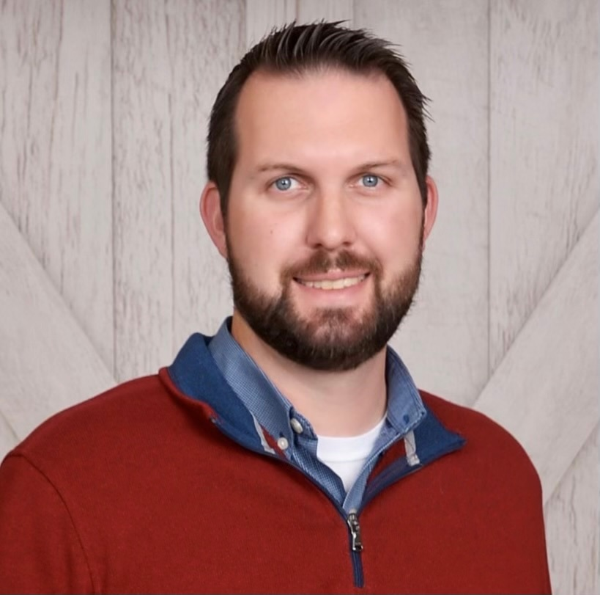
H. Nate Bachman is the Physics Discipline Manager and Interpretation Engineering NMR Advisor at the SLB Houston Formation Evaluation Center. He received a BS degree in physics from Valparaiso University, Indiana, USA and a PhD in physics from Northwestern University, Illinois, USA. He held a research associate position at Harvard University, Massachusetts, USA after which he joined SLB. Nate has worked for over two decades on research and engineering relating to NMR logging tools and applications, including 2 years of research at the Dhahran Carbonate Research Center in Saudi Arabia. Nate was an SPWLA Distinguished Speaker in 2015, and is a member of SPE, SPWLA, and the American Physical Society. Nate is currently serving as the SPWLA NMR SIG executive board president.
Kristopher Farmer is a petrophysicist with the Integrated Reservoir Solutions division of Core Laboratories. Prior to his current position Kris gained experience in core analysis while working in several laboratory roles across Core Laboratories including group leader in charge of laboratory operations for the Nuclear Magnetic Resonance group.
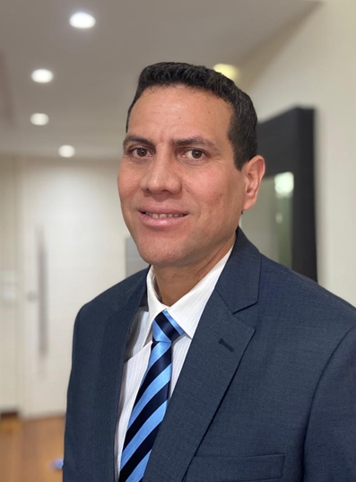
Kris holds a BS in Geology from Lamar University and a MS in Geology from Sul Ross State University. He is a board member of the SPWLA NMR SIG (Special Interest Group). His work is focused on core to log integration developing multi-variate surface relationships to characterize subsurface reservoir properties. This includes integration of advanced logging suites such as wireline NMR to improve target selection and reduce uncertainties in reservoir parameters.
Jesus P. Salazar is a petrophysicist working for Baker Hughes in Rio de Janeiro, Brazil since 2013. He joined the oil and gas industry in 1999 and currently, is the Formation Evaluation Advisor for Brazil. He was graduated in Physics in the Central University of Venezuela in 1999, received his MSc in Geophysics in the same university and his PhD in Geophysics in the National Observatory of Brazil. His special interest is the application of NMR and Acoustic technology for formation evaluation.
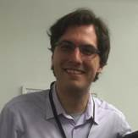
Willian Andrighetto Trevizan works in Petrobras Research Center (Cenpes) where he develops activities and research related to formation evaluation, petrophysics and well logging interpretation, mainly focused on Nuclear Magnetic Resonance and Image logs.
In the field of NMR, he contributed to the development of upscaling strategies for core-log integration, as well as in NMR raw data processing which led to quality control strategies to ensure good quality LWD data in Petrobras. He works with the application of AI techniques to anticipate logging information in real time, such as predicting well logs at the drill bit and enhancing the resolution of real time image logs, and in predicting patterns in image logs to assist interpretation. He is a Physicist with a Doctorate degree from University of Sao Paulo, and a 2023-2024 distinguished speaker for SPWLA.

