Workshop 5 Course Title: Towards the effective use of borehole acoustics; Understanding, validating and utilizing sonic measurements.

Date: Sunday May 19, 2024

Summary
This course will provide a grounding in the principles of borehole acoustic measurements in both simple and more complex conditions, along with quality control techniques to ensure reliable data is obtained, and case studies showing how the results can be used for a variety of applications. This course will cover both wireline and LWD conveyances and explore the different acquisitions, capabilities, and applications of each and the case studies presented will cover both Brazil and international examples. Additionally, attendees would also be encouraged to bring their own case studies and examples for group analysis and discussion.

Expectations (what you will get)
Attendees can expect to obtain a solid overview of the theory behind wave propagation in a borehole, how the needed measurements are made, processed, quality checked, and interpreted and then applied to solve a number of real-world problems.

Workshop 5 Course Outline (Timing Goal: 8.5 hours total including breaks)

Presenters: Brian Hornby (Hornby Geophysical Services, LLC.), Matthew Blyth (SLB), Philip Tracadas (HAL), Tiago de Bittencourt Rossi (Petrobras), Heitor Darrigo (Shell)

This workshop will cover the following topics:
- Overview of wave propagation in a borehole (head waves and dispersive borehole modes)
- Overview of industry logging tool principles (wireline and LWD)
- Environmental concerns for effective acoustic logging
- How we obtain slowness answers from waveform data (STC processing and dispersive processing techniques) and how we ensure they are correct
- What is acoustic data used for? Sonic applications and case studies:
  - What exactly is anisotropy, and why should I care?
  - Geophysics and the connection to seismic data.
  - The petrophysical applications of acoustics.
  - Fracture conductivity analysis and connection with borehole wall imaging
  - Geomechanics and wellbore stability.
  - Imaging beyond the wellbore and where it could go in the future.

Who Should Attend? Geophysicist, Geomechanics, Geologists, Petrophysicists, Well Production designers. This workshop is open to all symposium attendees who are interested in an introduction or to expand their knowledge of the acquisition, quality control and application of borehole acoustics measurements, with a particular focus on obtaining a better understanding of what really is “fit-for-purpose” data.
Prerequisites: Although no pre-existing knowledge of borehole acoustics is required to attend this course, it would be in all attendees benefit to have been exposed to the basic theory beforehand (ie. summary at Acoustic logging - PetroWiki (spe.org)). All attendees are encouraged to bring approved sonic log examples/application case studies for off-the-record group discussions..
Teaching Methods / Handouts: This course will be in person and discussions will be off the record to encourage participation. Virtual participation will not be available. Training materials will be available for attendees to download after the course.

Workshop 5 Course Instructor Biographies:
Brian Hornby leads efforts at Hornby Geophysical Services which focuses on products for downhole acoustic and elastic wave measurements. Brian started his career in 1983 as a field engineer with Schlumberger, ending up with research scientist positions in Schlumberger-Doll Research and Cambridge Research labs where he focused on advanced solutions for borehole sonic measurements and Rock Physics solutions. Next in 1996 Brian joined ARCO and then BP with the merger where he was a Senior Geophysical Advisor with a focus on borehole geophysics, including 3D VSP imaging and reservoir monitoring using permanent borehole sensors, including DAS (Distributed Acoustic Sensing). After BP Brian joined Halliburton in 2016 as Chief Scientific Advisor for Acoustics where he led efforts focused on advanced borehole sonic answer products, leaving Halliburton in 2020. Brian’s work experience in both Oil Companies and Oil Service Companies has given him the background and experience needed to successfully drive new technologies to a place where business value and commercial success is achieved.

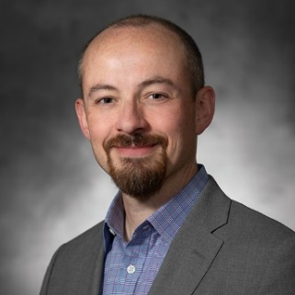
Matthew Blyth is the LWD Acoustics, Geophysics and Geomechanics Domain Head with SLB Well Construction. Over a 26 year career with SLB he has filled a variety of roles, all within the field of logging while drilling. He is currently involved in the long-term technical development plan for LWD acoustic and seismic technology within SLB and their applications. He has authored and co-authored multiple papers on LWD technology and its uses. He has served as both a vice president and as President of the Houston SPWLA chapter and the SPWLA NA2 Regional Director, he is on the board of the SPWLA Sonic SIG, was on the committee organizing the 2019 and 2023 SPWLA Annual Symposiums and was a 2016/2017 and 2020/2021 SPWLA Distinguished Speaker.
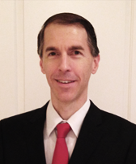
Philip Tracadas is a geoscientist subject matter expert for borehole acoustics at Halliburton. From 2013-2016 he served as Associate Editor for Acoustics for the SPWLA’s Petrophysics journal. Over the last decade, he has taught internal acoustic training, for wireline and while drilling tools, from basic to advanced products. With eighteen years of industry experience on various acoustic processing algorithms and tools, he liaises between log analysts, software developers, field operations, and customers to address formation challenges with effective and efficient tools.

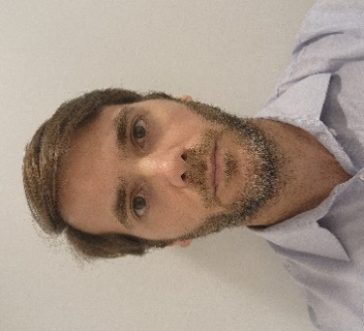
Tiago Rossi is a senior geophysicist at the petrophysics department in Exploration for Petrobras. From 2007 to 2011 worked in regional studies for the equatorial margin and interior basins of Brasil, focusing on basin and margin wide velocity modeling. Since 2011 moved to petrophysics to work with acoustics and well seismic, from planning operations to data processing and QC. He is currently responsible for all processed sonic data and well seismic data for all Petrobras. Since 2013 has been teaching internal courses in acoustics and geophysics in general.

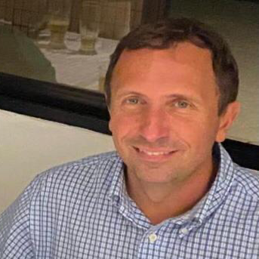
Heitor Darrigo is the principal geoscientist at the portfolio maturation team in Shell Brazil, working on the exploration and appraisal of Shell pre-salt held acreage in the outboard area of Campos Basin. From 2008-2016 he worked on the appraisal and development of some of the largest pre-salt discoveries in Santos Basin (Sapinhoa, Tupi, Iara and Lapa) in a variety of non-operated positions both for BG Group and Shell. From 2003 to 2008 he worked as geophysical advisor for Hess Corporation Houston office in several exploration and producing assets located in Brazil and Africa’s South Atlantic Basins and in the Gulf of Mexico. With 20+ years of industry experience, Heitor incorporated a variety of skills and workflows related to the integration of different geophysical tools for the characterization of discovered and undiscovered hydrocarbon maturation projects, including both clastic and carbonate reservoir types.

