Workshop 7 Course Title: Energy Transition Petrophysics – CCUS – What is New and What is the Same

Date: Sunday May 19, 2024

Summary
For this 2024 Energy transition petrophysics educational workshop we will discuss " the need of this transition, what do we need from A to Z to make this transition smooth, effective and how to generate well-trained work force”.

Expectations (what you will get)
Participants will be introduced of fundamental needs for the Carbon capture, utilization, and storage. We will talk about the Reservoir evaluation techniques for both OH and CH environment. We will discuss the importance of Formation pressure testing/Sampling and injection testing. Next, we will cover the Reservoir Surveillance/ monitoring (Near and Far) and saturation changes.

Workshop 7 Course Outline (Timing Goal: 9 hours total including breaks)

- 08:00am Introduction of Course and Instructors (30 min)
Monica Guerrero (Baker Hughes), Adam Haecker (Milestone Geosciences), Dler Mirza (Aker BP), David Chace (Baker Hughes) and Sami Eyuboglu (Halliburton)
- 08:30am Set the stage for data requirements (30 min) – Adam Haecker
Summary of US EPA site evaluation guidelines
- 09:00am OH Reservoir Evaluation (60 min) – Adam Haecker
Storage Capacity, Injectivity, Impacts of Heterogeneity
- 10:15am Formation Testing and Sampling (60 min) – Sami Eyuboglu
Pressures, Capturing Samples, Closure Pressure/Frac Gradient and Injection Testing
- 11:15am Reservoir Surveillance and Monitoring (45 min) – Dler Mirza
Near Field to Far field overview: Compartmentalization impact on optimal HC production
- 12:00pm Lunch
- 01:30pm Well Integrity (45 min) – Monica Guerrero
Cement and Tubulars.
- 02:15pm Saturation Analysis (45 min) – David Chace
Saturation Changes/Injectivity Conformance
- 03:15pm Reservoir surveillance and monitoring – Far Field (45 min) – Dler Mirza
Can 4D seismic processing on regional 3D surveys give insight to facies distribution in deep marine reservoirs?
- 04:00pm Open Discussion and Wrap Up (60 min)
Who Should Attend? Any geoscientist, petrophysicist, data scientist, or petroleum engineer with an interest in Carbon Capture, Sequestration and Storage.
Prerequisites: Anyone
Teaching Methods / Handouts: The course will be in person and discussions will be off the record to encourage participation. Virtual participation will not be available. Printed content will be provided.
Workshop 7 Course Instructor Biographies:
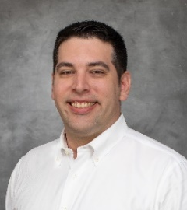 | Adam Haecker works in Houston as a Director of Geoscience for Milestone Carbon, a company dedicated to delivering CO2 sequestration solutions. His research interests include supercritical CO2 relative permeability, advances in MICP, organic shale petrophysics, and rock mechanics. Prior to Milestone, Adam worked as a petrophysicist for Battelle Memorial Institute, Continental Resources, Chesapeake Energy, and Cabot Oil and Gas (now Coterra), as well as Weatherford Wireline as a field engineer. Adam graduated from Texas A&M in 2007 with a B.S. in Geology.
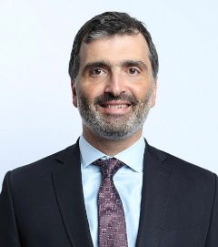 | Sami Eyuboglu is the Global Advisor for Formation Testing and Sampling domain in Geoscience & Production Team for Wireline & Sperry PSLs based in Houston. He has Ph.D. degree in Applied Physics from University of Arkansas at Little Rock. He has been working with for Halliburton since 2008 following a Post- Doctoral Associate in School of Earth Sciences from The Ohio State University in US. He has held various technology, operations, sales and business development positions in US and Saudi Arabia.
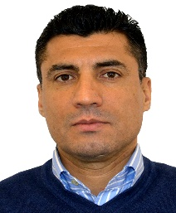 | Dler Mirza is Advanced Petrophysicist (Skarv asset) at Aker BP in Stavanger. He has MS degree in reservoir engineering from the University of Stavanger. He joined Logtek AS in 2008 and Aker BP in 2019. He is the President for the Norwegian Formation Evaluation Society (NFES). His general interests are within logging tool physics, petrophysical interpretation of reservoir properties, model building and wellbore data digitalization.
 | Monica Guerrero is Cased Hole Advisor, for Latin America, in Baker Hughes Reservoir Technical Services, where she advises on well integrity technology solutions on projects. She holds a Petroleum engineering degree, from Escuela Politécnica Nacional del Ecuador and a master’s degree in project management. Monica has 15 years with Baker Hughes with a career focused on log applications, analysis, and interpretation. Her previous assignments include Cased Hole Specialist Geoscientist for USA & Latin America and Wireline Applications Engineer in Ecuador.
 | David Chace is the Global Senior Petrophysics Advisor for Baker Hughes’ Reservoir Technical Services (RTS) Well Production & Integrity group based in Houston, Texas. He has over 43 years of industry experience, specializing in pulsed neutron cased hole logging technologies and interpretation methods for formation evaluation and production logging. He has authored/co-authored over 40 professional technical papers and holds 27 US patents. He has a BS degree in Physics from the University of Rhode Island.

